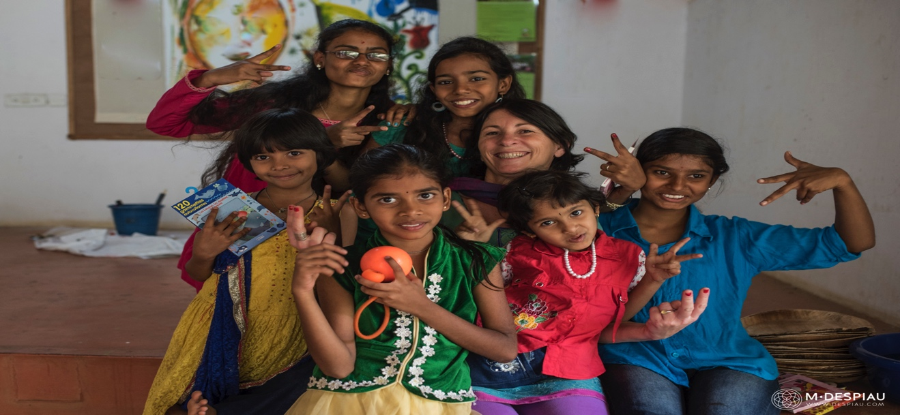

Introduction
To ensure that we make your stay at Annadana a memorable one, we request the following information.
This will help us understand your requirements better. Please fill your response & e-mail to us.

Note
- If you are visiting with your partner or friends, please use a separate Form to provide their Information
- The accommodation is subject to availability.
- We serve a simple, organic, vegetarian food. Food includes Breakfast, Lunch, Dinner & Refreshments
- Annadana can help make arrangements based on your specific interests (eg: Yoga/Sight Seeing/Transport, etc)

Contact
Do you need any other detail.? Please feel free to get in touch with us.
- interns@annadana-india.org
- Phone : +91 80 23254400
- Mobile : +91 8277116606
- Web: http://www.annadana-india.org

General Information

Your Name

Nationality

Occupation

Organization (if you are working for any Company, etc)

Age

Gender

No. of people (anyone accompanying you to Annadana)

Reference (where did you hear about Annadana)

Your Contact details (e-mail & Phone)

Emergency Contact details (include –Contact name, phone no & address)

Include relationship to you?

Your Itinerary

Arrival Date at Annadana

Departure Date from Annadana

Duration of Stay at Annadana
Do you need accommodation on the farm? | - Yes  - No
Type of accommodation required | - Room  - Single or double
Do you want Annadana to arrange for your food? | - Yes  - No

Please describe any medical conditions or special needs that may be an issue during your internship/volunteering. (Limited mobility, food allergies, etc…)

Your Interest

Your specific Interest for internships (what you want to do at Annadana?)

Your Primary Skill Set (eg: student Educator, Nurse, Artist, etc)

Why have you chosen to intern at Annadana?

Previous experience of organic farming / activities if any

Describe your learning/working style. Are you comfortable working independently with minimal supervision?

Are there any specific expectations from Annadana?

What skills or knowledge would you bring to Annadana? How will you contribute?

Hobbies, interests, anything else you wish to share?

We thank you for your interest in interning with Annadana

