SINCE 2001 SEED CONSERVATION

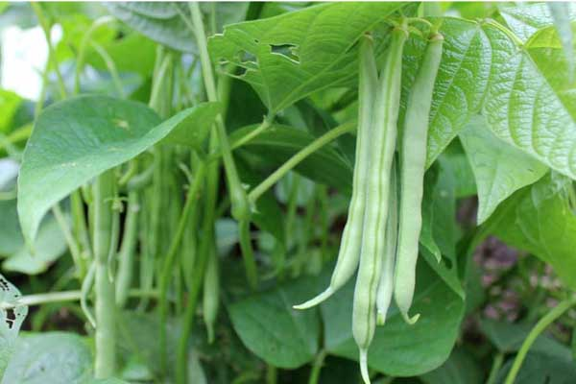
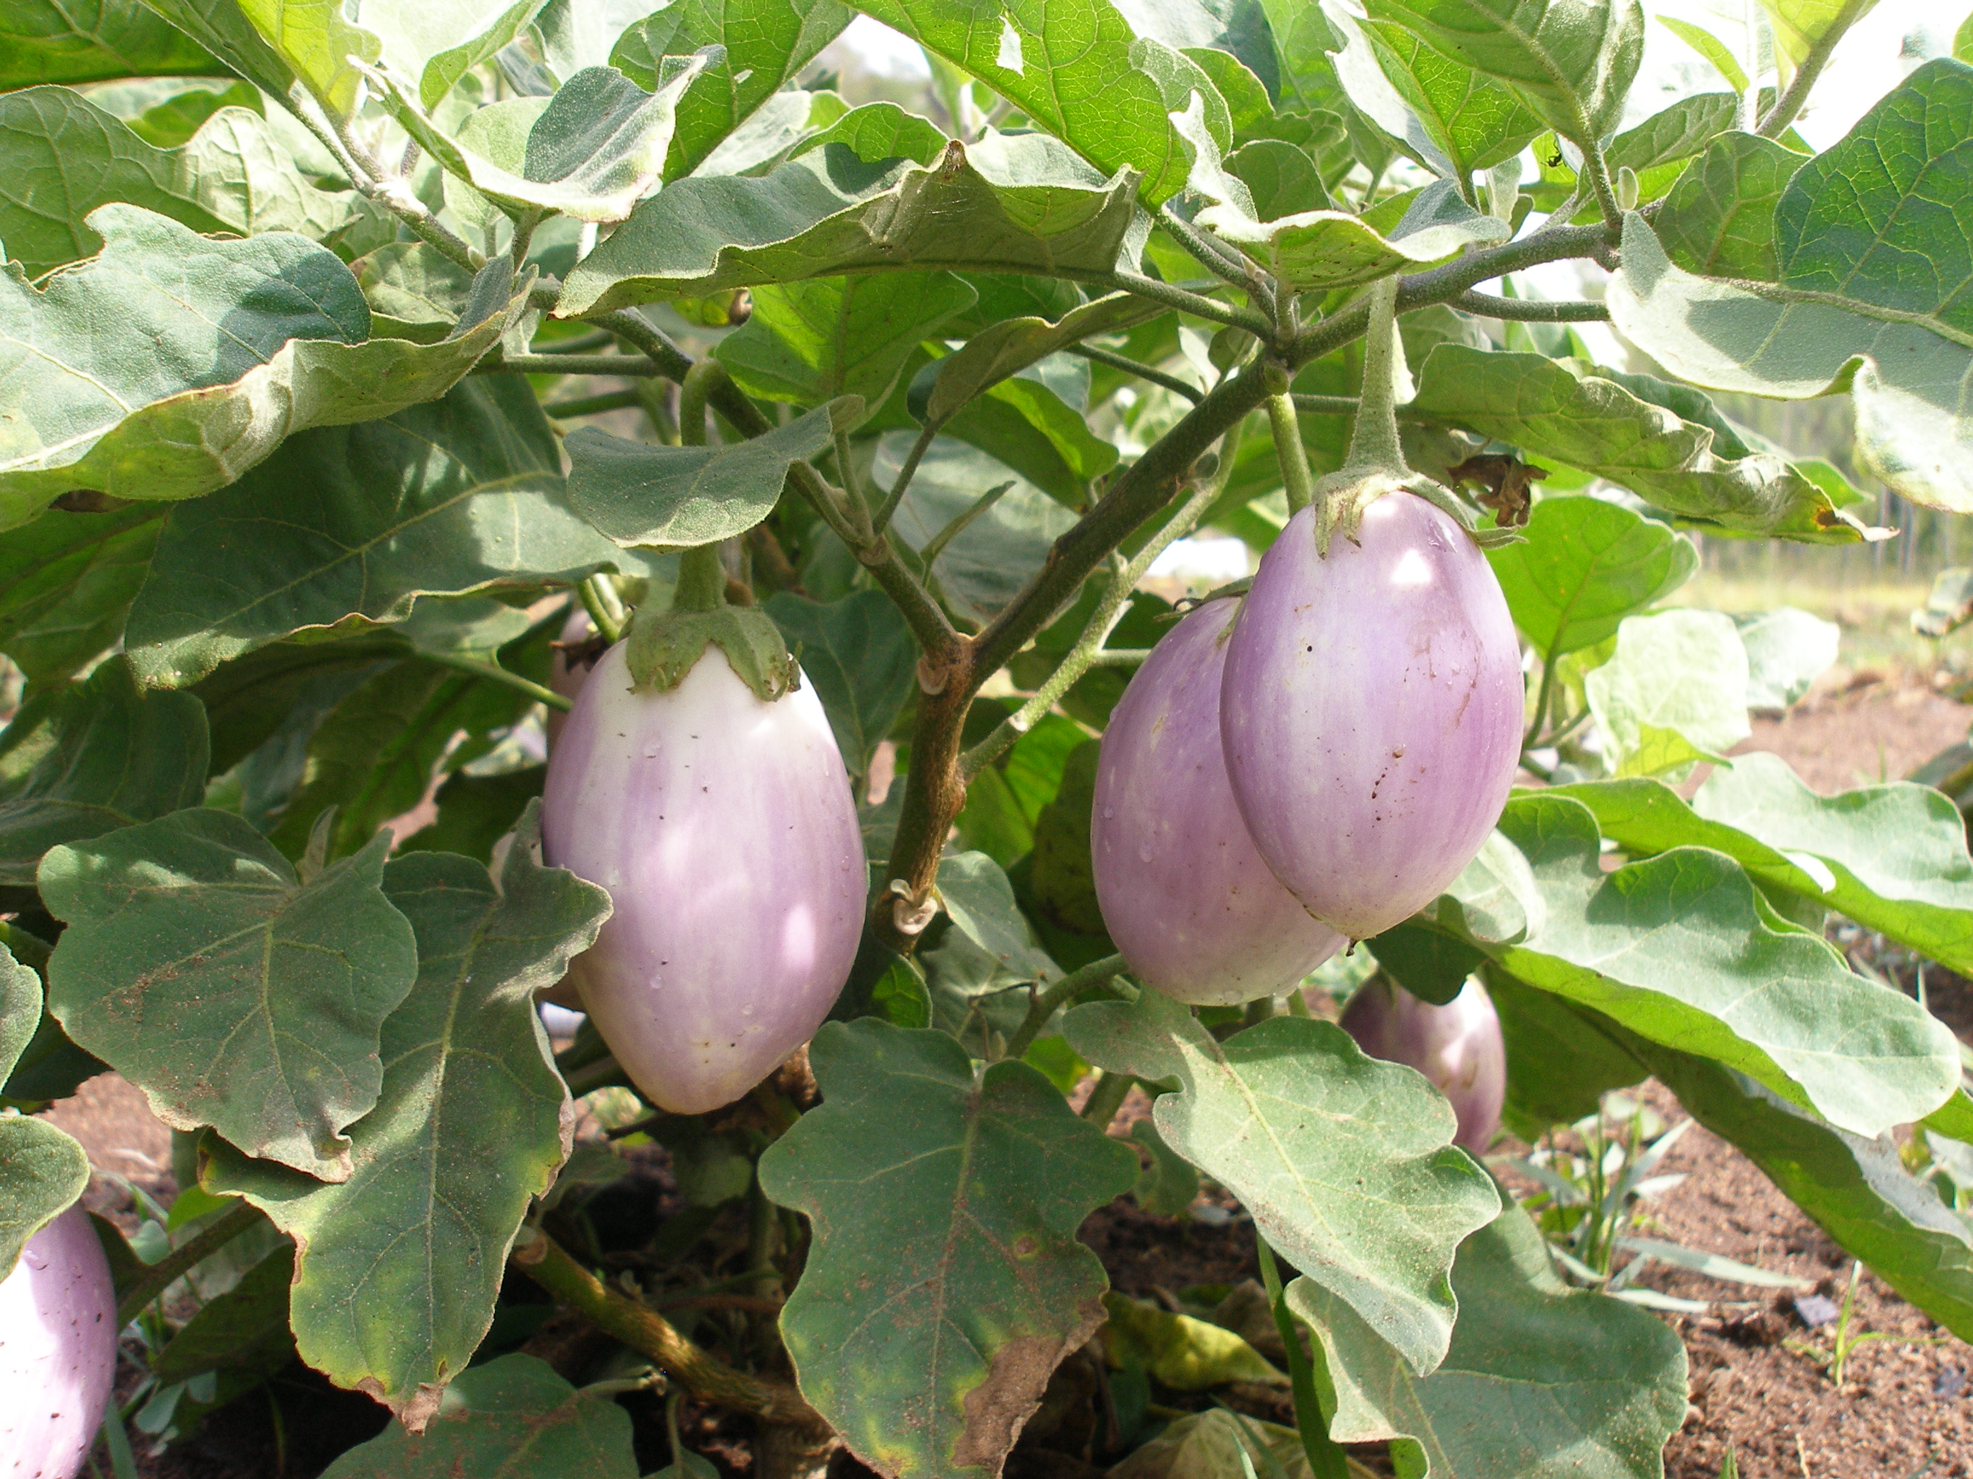
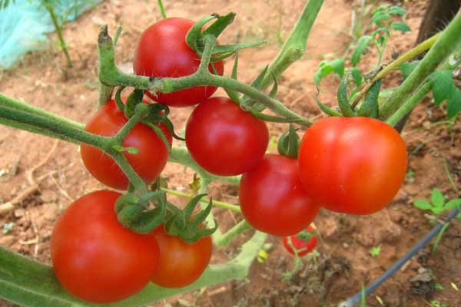

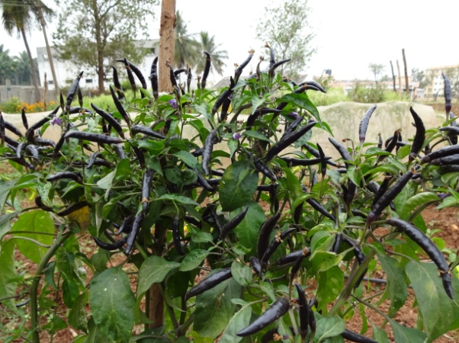
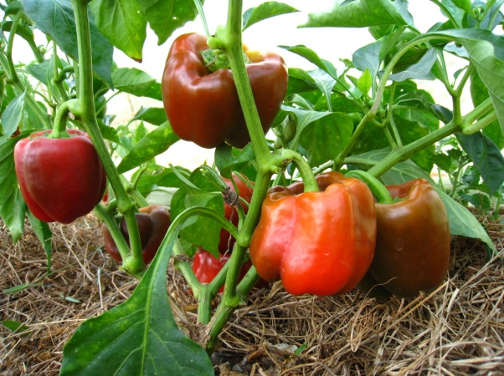
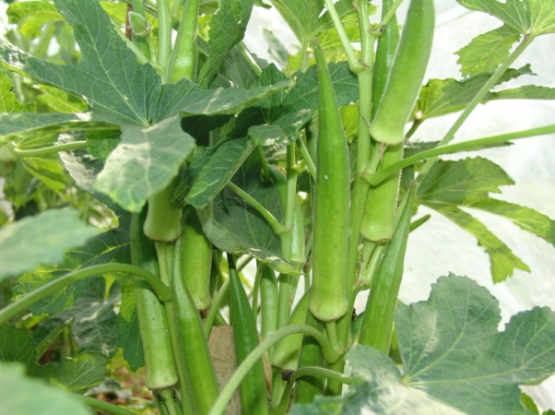

ORGANIC VEGETABLE SAPLINGS
ORDER FORM

Crop: Tomato
Variety: Meghali
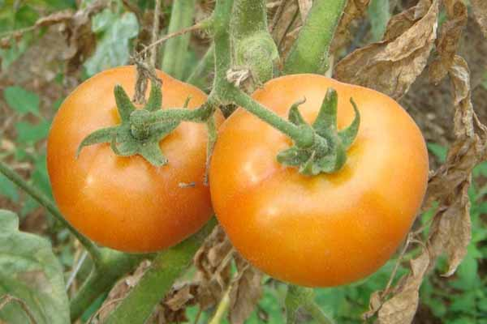 These plants produce red medium- sized fruits. They are excellent for curries. A high yielding variety

Time required for your order: 30 days

Crop: Tomato
Variety: Galina
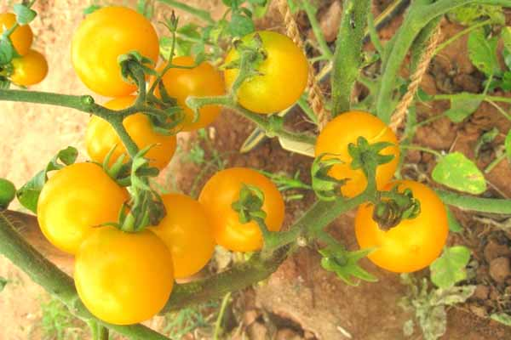 This early variety produces heavy clusters of round golden yellow cherry tomatoes. The flavor is juicy, sweet and acidic at the same time. These plants are very vigorous and high yielding. In-determinate growth

Time required for your order: 30 days

Crop: Tomato
Variety: Podland Pink
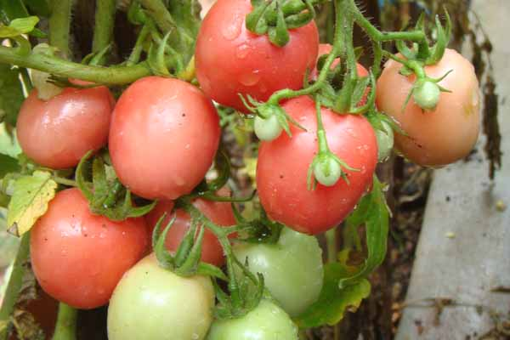 The vigorous vines produce abundant trusses of small oblong exotic fruits. These fruits have a unique color: they turn from pale yellow to pink when fully ripe. This variety is fully drought resistant and excellent for kitchen gardens.
Time required for your order: 30 days

Crop: Tomato
Variety: Red Cherry
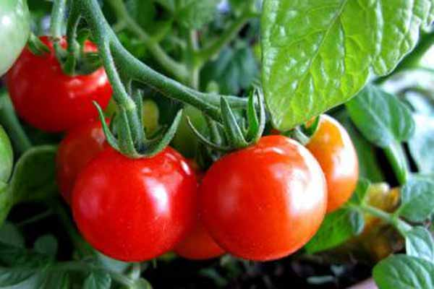 A compact bushy variety which grows up to 60 -80 cm height. Produces tiny round attractive red fruits which looks like cherries and very juicy. Fruits are used to make delicious salads.

Time required for your order: 30 days

Crop: Chilly
Variety: Long Green
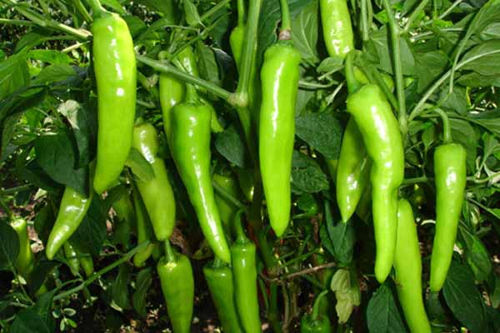 The fruit is 5- 10 cm long; it is a mildly hot variety. Plant is tall and compact. High yielding farmers variety and excellent for kitchen gardens.

Time required for your order: 30 days

Crop: Chilly
Variety: Red Cherry
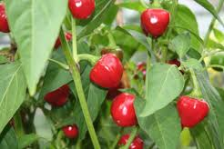Fruit is small, red, and round. Plants are tall and grow up to 1.5m height. It is typically used fresh, or pickled and jarred.

Time required for your order: 30 days

Crop: Brinjal
Variety: Apple Green
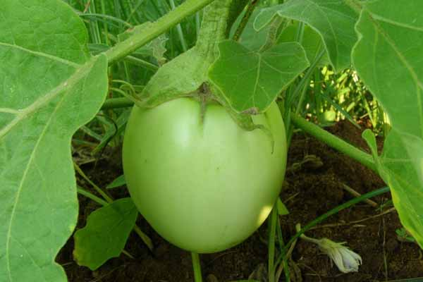 The oval to round fruits is light green in colour and weighs around 120 gram. The flesh is white, tender and mild-flavoured. Good for cooking as the fruit bear few seeds. The plant grows 60-90 cm tall and is pretty productive.
Time required for your order: 30 days

Crop: Brinjal
Variety: Purple Long
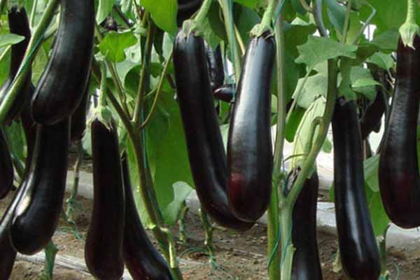 Plants are compact and bushy. Leaves and stem are greenish purple in colour. Fruits are oblong and deep purple in colour.

Time required for your order: 30 days

Crop: Brinjal
Variety: Purple Round
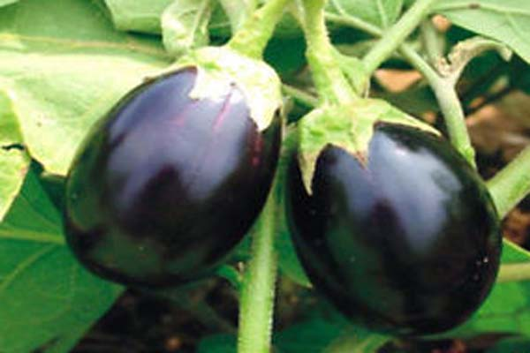 The plants are tall with a thick stem of greenish purple colour. Leaves are highly serrated and deep purple in colour. Fruits are round with purple colour. Each fruit weighs on an average 130-140 gr.

Time required for your order: 30 days

Crop: Basil
Variety: Aromatic Green
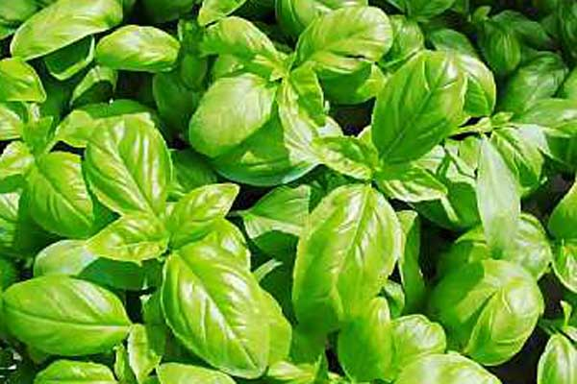 This variety has a good fragrance. The leaves are of medium size and are used for Italian cooking. The leaves can be dried after the seed extraction processes and conserved to be used at a later date. It’s a kitchen gardeners delight.
Time required for your order: 30 days

Crop: Beans
Variety: Green Gold
It is a string less and high yielding variety. This is a 60 day crop for food production. It’s a home gardener’s delight.

Time required for your order: 7 days

Crop: Bottle Gourd
Variety: Long Edible
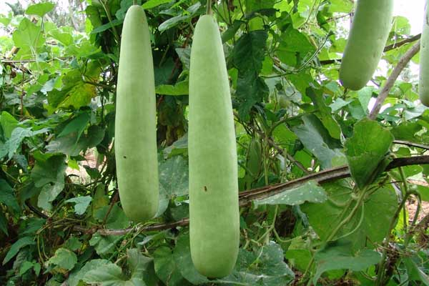 The fruits of this local variety of gourd can reach 60 cm long and 10 cm diameter. The skin is light green. The taste is sweet.

Time required for your order: 7 days
Crop: Ladies Finger
Variety: Clemson Spineless
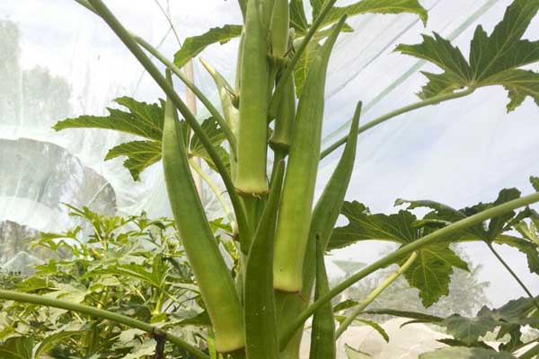 The very vigorous plants may grow up to 1m-1m60. The fruits are deep-green, smooth, pointed and slightly ribbed. They are 15 - 18 cm long.

Time required for your order: 7 days

Crop: Ridge Gourd
Variety: Long Green
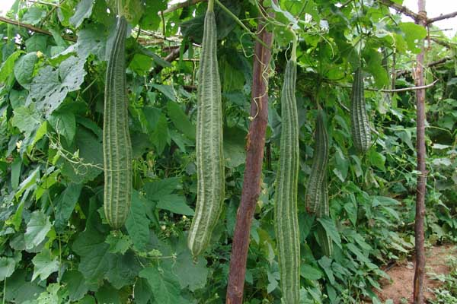 Adapts to warm climate, very productive. Good source of carbohydrates, vitamin A, vitamin C and minerals. Excellent for kitchen gardens & farmer friendly variety.

Time required for your order: 7 days

Crop: Lettuce
Variety: Winter Marvel
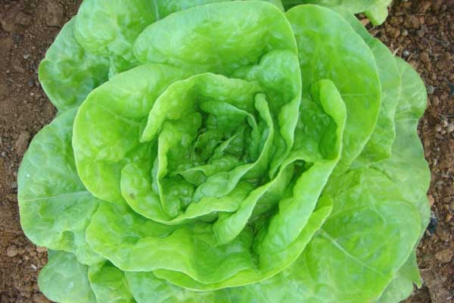 The smooth, slightly wavy and pale green leaves form a large head. This variety is extremely resistant to cold. It is a winter crop.

Time required for your order: 30 days

Crop: Carrot
Variety: Nantaise
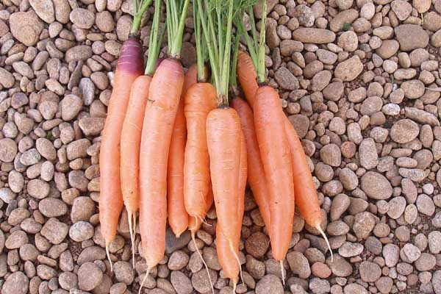 A sweet juicy carrot with red-orange colour is cylindrical and 15cm long; grows well in most soil types and cool climate.

Time required for your order: 30 days

Crop: Cucumber
Variety: Long Green
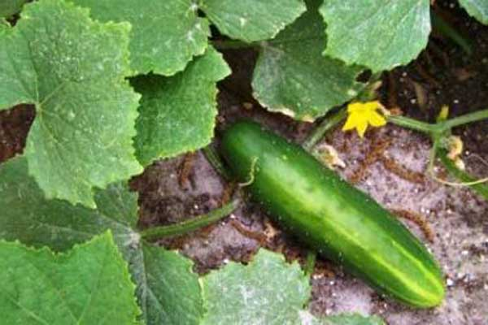 A ground creeper plant. Similar to Green Market but longer and greener in colour. Takes about 5 days to germinate in coco peat.

Time required for your order: 7 days

Crop: Corn
Variety: Popcorn Yellow
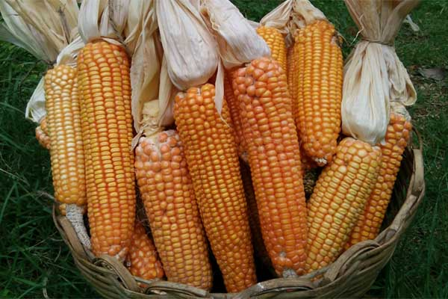 The very nice 10-12 cm long ears while some are dark. This makes beautiful yellow popped corn. The plants grow to 2 meters. From direct sowing: 80 days.

Time required for your order: 7 days

Species | Variety | No. of saplings Required | Required timeframe to fulfil your order
Tomato | Meghali |  | 30 days
 | Galina |  | 30 days
 | Podland Pink |  | 30 days
 | Red Cherry |  | 30 days
Chilly | Long Green |  | 30 days
 | Red Cherry |  | 30 days
Brinjal | Apple Green |  | 30 days
 | Purple Long |  | 30 days
 | Purple Round |  | 30 days
Basil | Aromatic Green |  | 30 days
Beans | Green Gold |  | 7 days
Bottle Gourd | Long Edible |  | 7 days
Carrot | Nantaise |  | 30 days
Cucumber | Long Green |  | 7 days
Corn | Popcorn Yellow |  | 7 days
Ladies Finger | Clemson Spineless |  | 7 days
Ridge Gourd | Long Green |  | 7 days
Lettuce | Winter Marvel |  | 30 days

COSTS
Below 100 saplings | 100-200 saplings | Above 200
Rs. 50/- | Rs. 40/- | Rs. 30/-

Terms & Conditions:
- 50% advance payment & 50% upon delivery
- Non-refundable advance
- Transportation charges extra and on actuals

Bank Transfer Details
Name of the Organization | Annadana Eco Organic Private Limited
Bank Name | State Bank of India
Branch Area | Jalahalli East, Bangalore
Account No. | 35028810131
Type of Account | Current Account
IFSC Code | SBIN0000963
SWIFT Code | SBININBB177
PAN Number | AANCA5556D

